NEW PLYMOUTH ADVENTIST CHRISTIAN SCHOOL
Stationery Middle Class 2023
Books
All books need to be clearly named. Please do not cover them as this hides the print and topic based words that come printed on the book.
MATHEMATICS
2x Clever Kiwi Fun Doing Maths Exercise Book 1
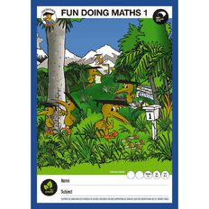
WORD WORK, BIBLE, THEME
5 x Clever Kiwi Activities Book Blank 100gsm 34 Leaves
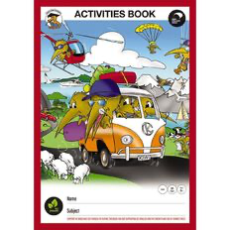

WRITING
2x Clever Kiwi My Writing Book 12mm 2x Clever Kiwi Writing Exercise Book 9mm
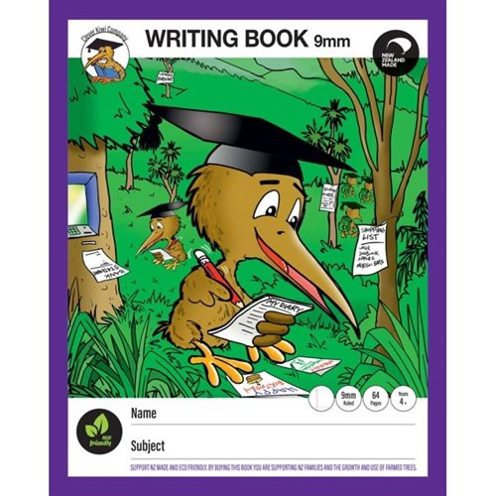
(Year 2 & 3) (Year 4+)
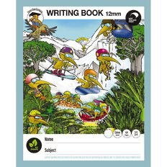

Poem Book
1x1A8 blank pages
​
​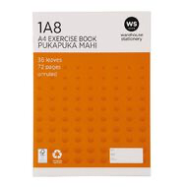
HANDWRITING
1x 1LWB Learn to write book
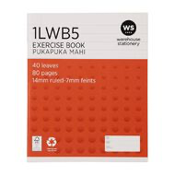

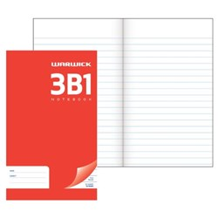
Spelling notebook
2x 3B1

HOMEWORK Book
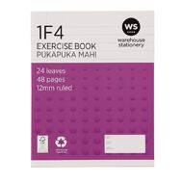
1x 1F4
1x BOOKBAG
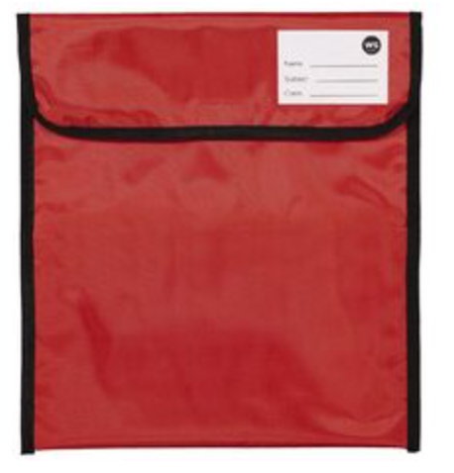

STATIONERY
All stationery needs to be clearly named
- 5x blue pens
- 2x red pens
- 4x grey led pencils
- 2x eraser/rubber
- 1x ruler - 30cm
- 5x glue sticks (AMOS brand-other brands are no good)
- 1x pencil sharpener
- 1 x scissors
- Own pencil case
- Headphones (if new ones needed)
- Coloured pencils
- Crayola brand felt pens
- 3x Vivid (black permanent marker)

The following equipment will be shared in the classroom throughout the year therefore it does not need to be named.
- Box of tissues
- 2x White board markers
- Ream of A4 photocopier paper
PURCHASE THROUGH THE OFFICE:

Math Workbook - $12 this will be added to your account, possibly 2 for the year.

